Home Page
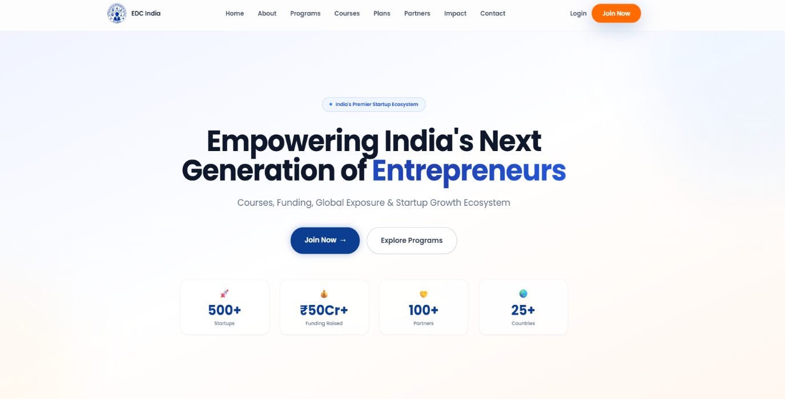
Tagline:
👉 Entrepreneurship is not just about starting a company — it’s about building a mindset.
🌍 ABOUT EDC INDIA
Headline:
👉 Who We Are
Content:
Entrepreneurial Development Council (EDC India) is a mission-driven organization working to build and strengthen the entrepreneurial ecosystem across India and globally.
Since 2019, we have been actively working to spread entrepreneurial awareness, enable innovation, and help individuals understand that entrepreneurship is not limited to starting a startup — it is a way of thinking, solving, and creating impact.
From students to founders, universities to policymakers — we connect every layer of the ecosystem.
Today, EDC India operates across India, UAE, and Singapore, collaborating with:
- 70+ Universities
- 100+ Institutes
- 500+ Startups
- 3,000+ Members
👉 And we are just getting started.

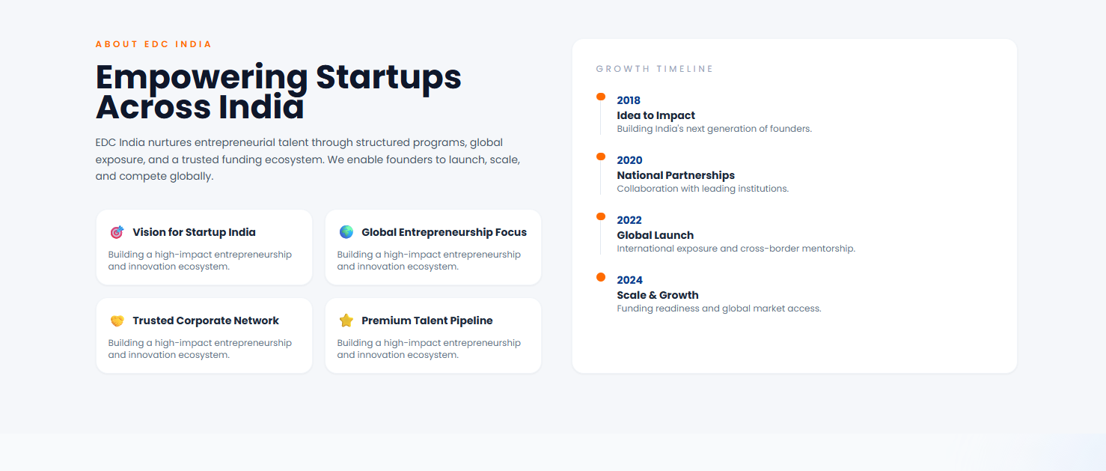
🚀 OUR MISSION
Headline:
👉 Our Mission
Content:
To build a strong, inclusive, and practical entrepreneurial ecosystem where individuals don’t just learn — they build, execute, and grow.
We aim to:
- Promote entrepreneurial mindset across students and institutions
- Support startups from idea to scale
- Bridge the gap between education, industry, and innovation
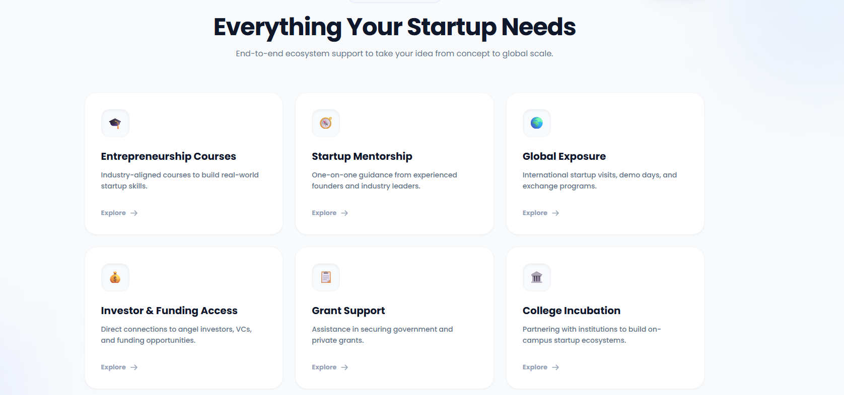
💡 WHAT WE DO

🔍 1. Idea Validation
Headline:
👉 Validate Before You Build
Content:
Most people don’t even know whether their idea is a startup, a business, or just a concept. They chase funding without clarity.
At EDC India, we help you:
- Understand your idea stage
- Evaluate market potential
- Identify whether you are ready for funding, incubation, or acceleration
👉 Get a detailed validation report and clear direction for your next step.
CTA:
👉 [Validate Your Idea Now]

🤝 2. EDC Membership
Headline:
👉 Join India’s Growing Entrepreneurial Community
Content:
Our 1-Year Membership is designed to give founders, students, and innovators everything they need — all in one place.
What you get:
- Monthly workshops & networking meetups
- Investor pitch opportunities
- Founder doubt-solving sessions
- Access to startup events across India
- Updates on funding, grants & opportunities
- Support in pitch, finance, and growth
Membership Fee:
👉 ₹2,500 / Year
CTA:
👉 [Apply for Membership]

🎓 3. Entrepreneurial Fellowship
Headline:
👉 Build Your Startup in 1 Year
Content:
The EDC Entrepreneurial Fellowship is a 1-year intensive program designed to help individuals build startups from scratch.
Program Structure:
- 30% Theory + 70% Practical Execution
- Real startup building experience
- Mentorship from industry experts
Opportunities after Fellowship:
- Up to ₹10 Lakhs in Grants
- Up to ₹1 Crore in Equity/Debt Funding
- International exposure (Dubai / Singapore) for selected candidates
👉 This is not a course — this is a startup journey.
CTA:
👉 [Apply for Fellowship]

🏆 4. India Innovation & Incubation Ranking
Headline:
👉 India’s Most Transparent Startup & Incubation Ranking
Content:
EDC India conducts an independent, on-ground evaluation of colleges and universities to rank their performance in innovation and incubation.
Evaluation Criteria:
- Startup growth
- Incubation quality
- Funding support
- Job creation
- Innovation & patents
- Conversion of ideas into businesses
What Makes It Unique:
- 100% transparent process
- Physical visits by our team
- Real data-driven evaluation
Ranking Structure:
- Top 30 Incubation Centers
- Top 30 Startup Ecosystems
- Top 100 Student Innovation Projects
👉 Only the best make it to the list.
CTA:
👉 [View Rankings / Apply]

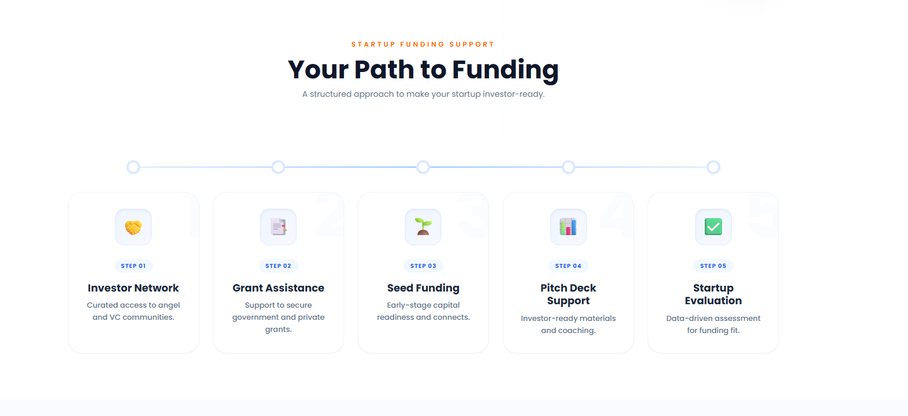
1. Idea Validation
2. Pitch and finance support
3. Pitch Presentation
4. Grant and fund Support
5. Growth

🌐 GLOBAL PRESENCE
Headline:
👉 Building Across Borders
Content:
EDC India is actively expanding its ecosystem globally, with operations and collaborations in:
- 🇮🇳 India
- 🇦🇪 UAE
- 🇸🇬 Singapore
👉 Connecting startups, investors, and institutions at an international level.

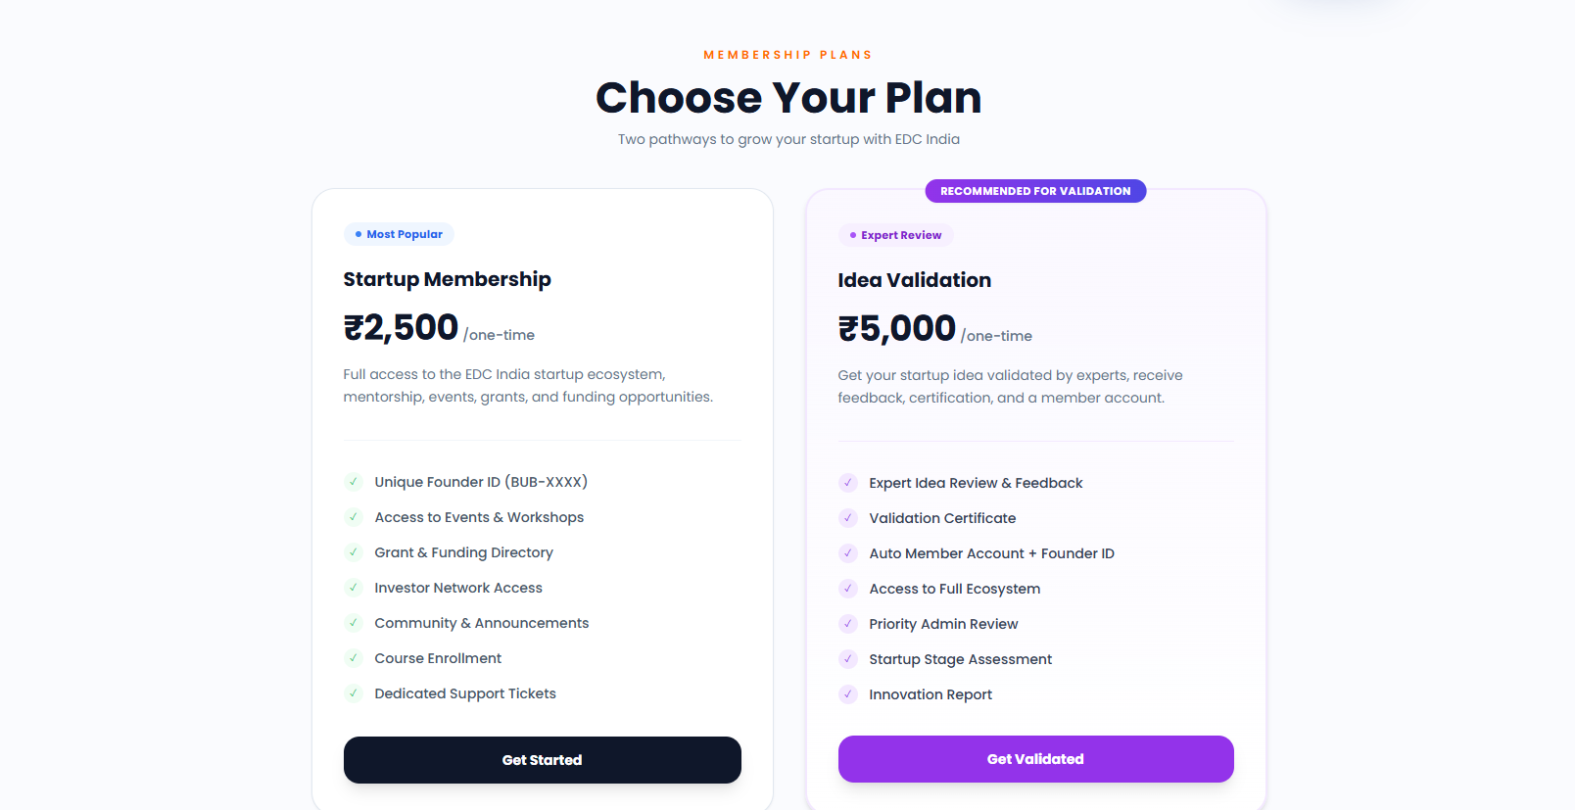
💥 FINAL CTA SECTION
Headline:
👉 Start Your Entrepreneurial Journey Today
Content:
Don’t just learn about startups — become a part of the ecosystem that builds them.
👉 Ideas need direction. Startups need systems. We provide both.
Page About US

🚀 ABOUT PAGE – EDC INDIA

🌍 WHO WE ARE
Entrepreneurial Development Council (EDC India) is a mission-driven organization dedicated to building and strengthening the entrepreneurial ecosystem across India and globally.
Founded in 2019, EDC India was created with a simple yet powerful belief:
👉 Entrepreneurship is not limited to starting a company — it is a mindset of solving problems, creating value, and thinking differently.
We work at the intersection of students, startups, universities, investors, and policymakers, enabling collaboration, innovation, and real-world execution.

🔥 OUR STORY
EDC India started as a vision to bridge a critical gap —
👉 the gap between education and real-world entrepreneurship.
We observed that while thousands of students graduate every year, very few understand how businesses actually work, how ideas are validated, or how startups grow.
At the same time, startups struggle with clarity, structure, and access to the right ecosystem.
This is where EDC India stepped in.
From conducting small sessions and meeting individuals one-on-one, we have now grown into a multi-layered ecosystem platform working with institutions, founders, and innovators across borders.

🚀 OUR IMPACT
Over the years, EDC India has built a strong and growing network:
- 70+ Universities
- 100+ Institutes
- 500+ Startups
- 3,000+ Members
- Presence in India, UAE, and Singapore
👉 And this is just the beginning.

💡 WHAT WE BELIEVE
At EDC India, we strongly believe:
- Entrepreneurship is a mindset, not a designation
- Not everyone needs to start a startup — but everyone should think like an entrepreneur
- Real learning happens through execution, not theory
- Sales, problem-solving, and adaptability are core life skills
👉 Degrees alone don’t create impact — skills and action do.

🎯 OUR MISSION
To build a strong, inclusive, and execution-driven entrepreneurial ecosystem where individuals can:
- Learn how to think and act like entrepreneurs
- Validate and build their ideas
- Access the right mentorship, funding, and opportunities
- Grow from idea to impact

🔗 WHAT WE DO
We create platforms, programs, and opportunities that enable:
- Idea Validation & Startup Clarity
- Community Building & Membership Access
- Entrepreneurial Fellowships
- University & Incubation Development
- Innovation & Incubation Rankings
👉 Our focus is not just to educate — but to enable action.

🌐 OUR ECOSYSTEM
EDC India brings together all key stakeholders of entrepreneurship:
- Students & Aspiring Entrepreneurs
- Startups & Founders
- Colleges & Universities
- Investors & Mentors
- Government & Policy Makers
👉 Creating a connected ecosystem where ideas turn into execution.

🔥 OUR VISION
To become one of the most impactful entrepreneurial ecosystem builders globally —
👉 enabling millions of individuals to think, build, and grow beyond limitations.

🤝 JOIN THE MOVEMENT
EDC India is not just an organization — it is a growing movement.
Whether you are:
- A student exploring your path
- A founder building your startup
- A college shaping future leaders
- An investor supporting innovation
👉 There is a place for you in this ecosystem.

💥 FINAL LINE (IMPORTANT)
👉 “We don’t just talk about entrepreneurship — we build the ecosystem that makes it possible.”

Fellowship page

🚀 EDC ENTREPRENEURIAL FELLOWSHIP

🔥 HERO SECTION
Headline:
👉 Build Your Startup & Career in 12 Months
Sub-headline:
👉 No experience? No idea? No problem. Learn, build, and grow with India’s most practical entrepreneurial fellowship.
Tagline:
👉 30% Learning. 70% Real Execution.
CTA Buttons:
👉 [Apply Now]
👉 [Book a Call]

💣 THIS IS FOR YOU IF…
- You are a student (BBA, MBA, or any field) confused about your career
- You want to build a startup but don’t know where to start
- You want to learn real skills instead of theory
- You lack confidence in communication, sales, or business
- You want practical exposure and real opportunities
👉 Even if you are starting from zero — this fellowship is for you.

🚀 WHAT IS EDC FELLOWSHIP?
The EDC Entrepreneurial Fellowship is a 1-year execution-driven program designed to help you:
👉 Understand business
👉 Build real skills
👉 Work on startup ideas
👉 Gain real-world exposure
This is not a course.
👉 This is a journey from confusion to clarity, and from learning to execution.

🎓 HOW THE PROGRAM WORKS
Duration: 12 Months
Fee: 10000/-
Model:
👉 30% Learning + 70% Practical Execution
Process:
- Learn basics in simple, practical way
- Work on real problems & ideas
- Practice communication & sales
- Execute with real exposure
👉 Learn → Practice → Execute → Grow

💡 WHAT YOU WILL LEARN
- How to think like an entrepreneur
- How to validate any idea
- How to communicate and pitch confidently
- How to sell a product or idea
- How startups actually work
- How to approach clients & opportunities
👉 Everything explained in simple language with real examples.

💰 FUNDING & OPPORTUNITIES
After successful completion of the fellowship:
- 💸 Up to ₹10 Lakhs Grant Support
- 💼 Up to ₹1 Crore Funding Opportunity (Equity/Debt)
- 🌍 International Exposure (Dubai / Singapore) for selected fellows
👉 We don’t just teach — we support your growth.

👨‍🏫 MENTORSHIP & EXPOSURE
- Learn from startup founders & industry experts
- Get guidance from real builders, not just trainers
- Exposure to startup ecosystem, events, and networks

🌍 GLOBAL EXPERIENCE
Top-performing fellows get a chance to explore international ecosystems in:
- 🇦🇪 Dubai
- 🇸🇬 Singapore
👉 Think global. Build bigger.

🎯 WHAT YOU WILL BECOME
After this fellowship, you will become:
- A confident communicator
- A problem solver
- A person who understands business & sales
- Someone who can earn through skills, not depend on degree
👉 This is not just learning — this is transformation.

❌ NO PRIOR EXPERIENCE NEEDED
You don’t need:
- Any business background
- Any startup idea
- Any sales experience
👉 We start from basics and take you to real execution.

🔥 WHY EDC FELLOWSHIP?
- Practical > Theory
- Real execution > Classroom learning
- Access to funding & ecosystem
- Strong network of colleges & startups
- Continuous support & mentorship
👉 We don’t just teach entrepreneurship — we build entrepreneurs.

💥 SELECTION PROCESS
- Apply online
- Shortlisting
- Personal interaction
- Final selection
👉 Limited seats. Only serious candidates.

🚀 FINAL CTA
Headline:
👉 Start Your Journey Today
Content:
You don’t need to be perfect.
You just need to start.
👉 If you are ready to grow, we are ready to guide you.
Buttons:
👉 [Apply Now]
👉 [Talk to Us]

⚡ POWER LINE (Footer)
👉 “Degrees don’t build careers. Skills and execution do.”

🚀 IDEA VALIDATION + EDC MEMBERSHIP (COMBINED PAGE)

🔥 HERO SECTION
Headline:
👉 Don’t Build Blindly. Validate Your Idea First.
Sub-headline:
👉 Get clarity, direction, and access to India’s startup ecosystem — all in one place.
Tagline:
👉 Validate → Build → Grow
CTA Buttons:
👉 [Validate My Idea]
👉 [Get Started]

💣 THE REAL PROBLEM
Headline:
👉 Why Most People Fail Before They Even Start
Content:
Most people jump into ideas without clarity.
They follow trends, copy others, or start building without understanding the market.
👉 And then:
- No customers
- No revenue
- No growth
👉 Not because the idea was bad… but because it was never validated.

🚀 WHY IDEA VALIDATION IS A MUST
Headline:
👉 Why You Should Validate Your Idea First
- Understand if your idea is a startup, business, or just a concept
- Check if there is real market demand
- Avoid wasting time, money, and energy
- Know if you are ready for funding or incubation
- Build with clarity and confidence
👉 Clarity before execution = higher success rate.

💡 WHAT YOU GET IN IDEA VALIDATION
Headline:
👉 Complete Idea Validation Report
- Idea stage clarity
- Market analysis
- Problem-solution fit
- Business model direction
- Strengths & risks
- Funding readiness
- Clear next action plan
👉 You don’t just get feedback — you get a roadmap.

💣 BONUS (HOOK SECTION)
Headline:
👉 And That’s Not All…
When you validate your idea with EDC India, you also get:

🚀 EDC MEMBERSHIP (FREE WITH VALIDATION)
Headline:
👉 1-Year EDC Membership — Included Free
Content:
Along with idea validation, you get full access to EDC ecosystem for 1 year.

🔥 MEMBERSHIP BENEFITS
- 📅 Monthly workshops & meetups
- 🎤 Investor pitch opportunities
- 🤝 Networking with founders & mentors
- 💬 Doubt-solving sessions
- 🎪 Access to startup events & stalls
- 📢 Updates on funding & grants
- 📊 Support in pitch, finance & strategy
👉 Everything you need — in one ecosystem.

💰 PRICING (SMART POSITIONING)
Headline:
👉 Simple & Powerful Pricing
- Idea Validation: ₹5,000
- EDC Membership (1 Year): ₹2,500
👉 Total Value: ₹7,500
🔥 Today You Pay Only ₹5,000
👉 And get 1-Year Membership FREE

🎯 WHO SHOULD APPLY
- Students with startup ideas
- Early-stage founders
- Anyone confused about their idea
- Anyone planning for funding or incubation
👉 If you have an idea — this is your first step.

🔥 WHY EDC INDIA
- Real ecosystem access
- Practical approach (not theory)
- Strong network (70+ universities, 500+ startups)
- Clear direction, not confusion
👉 We don’t just guide — we give clarity + ecosystem.

🚀 FINAL CTA
Headline:
👉 Validate Your Idea. Unlock the Ecosystem.
Content:
Don’t waste months guessing.
Get clarity, direction, and access — all in one step.
👉 Your startup journey starts here.
CTA Buttons:
👉 [Apply for Idea Validation]
👉 [Join Now]

⚡ POWER LINE (Footer)
👉 “Right idea + right direction = real growth.”
🚀 INDIA INNOVATION & INCUBATION RANKING (IIIR)
By EDC India

🔥 HERO SECTION
Headline:
👉 India’s Most Transparent Innovation & Incubation Ranking
Sub-headline:
👉 Recognizing institutions, startups, and student innovators who are building real impact.
Tagline:
👉 Measured by execution. Recognized by impact.
CTA Buttons:
👉 [Apply for Ranking]
👉 [Download Brochure]

🌍 WHY THIS RANKING MATTERS
Headline:
👉 Beyond Traditional Rankings
Content:
Most institutional rankings focus on academics, infrastructure, and legacy.
But the world has changed.
Today, the real question is:
👉 Is your institution creating innovators, startups, and job creators?
The India Innovation & Incubation Ranking (IIIR) is designed to measure exactly that —
👉 real innovation, real execution, and real outcomes.

🚀 ABOUT IIIR
Headline:
👉 What is IIIR?
Content:
IIIR is an independent, transparent, and execution-driven ranking system that evaluates colleges and universities based on their actual contribution to:
- Startup ecosystem development
- Innovation output
- Incubation effectiveness
- Entrepreneurial culture
👉 This is not a perception-based ranking — it is based on real performance.

💡 OUR APPROACH
Headline:
👉 Verified. Transparent. Data-Driven.
Content:
Our evaluation model combines:
- 📊 Data analysis
- 🏫 Physical campus visits
- 🤝 Interaction with founders & students
- 📈 Performance-based scoring
👉 We don’t just review reports — we validate on ground.

📊 EVALUATION CRITERIA
Headline:
👉 What We Measure
- 🚀 Startup Growth
- 🏢 Incubation Quality
- 💰 Funding Support
- 👨‍💼 Job Creation
- 💡 Innovation & Patents
- 🔄 Idea-to-Business Conversion
👉 We focus on outcomes, not just activities.

🏆 RANKING STRUCTURE
Headline:
👉 Recognizing Excellence Across India
Each year, IIIR identifies:
- 🥇 Top 30 Incubation Centers
- 🚀 Top 30 Startup Ecosystems (Institutions)
- 💡 Top 100 Student Innovation Projects
👉 Only institutions with real impact make it to the list.

🎖️ RECOGNITION & AWARDS
Headline:
👉 Recognition That Builds Authority
Selected institutions, startups, and students receive:
- 🏅 Official Ranking Certificate
- 🏆 EDC Recognition Memento (Trophy)
- 🎤 National-Level Recognition Platform
- 📢 Visibility Across EDC Ecosystem & Network

🌟 SPECIAL RECOGNITION
For Institutions:
- Official ranking certification
- National recognition for innovation & incubation excellence
For Startups:
- Recognition as high-potential startups
- Visibility among investors & ecosystem partners
For Students:
- Awards for top innovation projects
- Recognition for creativity and execution
👉 Your work gets the recognition it deserves.

🎯 WHY PARTICIPATE
Headline:
👉 Why This Ranking is Important for You
- Build national credibility & brand value
- Attract better students, startups, and partnerships
- Benchmark against top institutions
- Strengthen your innovation & incubation ecosystem
- Showcase real impact to government & stakeholders
👉 This is not just ranking — this is positioning.

🌐 GLOBAL VISION
Headline:
👉 Building a Global Standard from India
Content:
EDC India aims to make IIIR a globally recognized benchmark for measuring innovation and entrepreneurial ecosystems.
👉 From India to the world — setting new standards.

📝 APPLICATION PROCESS
Headline:
👉 Simple & Transparent Process
- Submit application
- Share institutional data
- On-ground evaluation by EDC team
- Final scoring & ranking
👉 100% transparent. 100% credible.

🤝 WHO CAN APPLY
- Colleges & Universities
- Incubation Centers
- Startup Ecosystem Builders
- Student Innovation Teams
👉 If you are building — you should be here.

🚀 FINAL CTA
Headline:
👉 Get Recognized for Real Impact
Content:
If your institution is creating innovation, building startups, and driving real change —
👉 it deserves national recognition.
CTA Buttons:
👉 [Apply for Ranking]
👉 [Connect with EDC]

⚡ POWER LINE (FOOTER)
👉 “Innovation is not what you claim. It’s what you build.”
apply now
for incubation
for startup
for students project

Mai google froms 2-3 din me bej dunga
or jab bhi apply karange ga
ek auto agree pe click hoga term and conditions
TERMS & CONDITIONS – IIIR (India Innovation & Incubation Ranking Awards)
By EDC India (Entrepreneurial Development Council)

1. Introduction
By applying to or participating in the India Innovation & Incubation Ranking (IIIR), all applicants (institutions, incubation centers, startups, and student teams) agree to the following Terms & Conditions set by EDC India.

2. Eligibility
- The ranking is open to colleges, universities, incubation centers, startups, and student innovators.
- Applicants must provide accurate and verifiable information.
- EDC India reserves the right to accept or reject any application without prior notice.

3. Data Submission & Accuracy
- All data submitted must be true, complete, and up-to-date.
- Any false, misleading, or manipulated information may lead to:
  - Immediate disqualification
  - Removal from ranking
  - Revocation of awards/certificates
👉 The applicant is solely responsible for the authenticity of submitted data.

4. Data Usage & Consent
By submitting the application, you agree that:
- EDC India may collect, store, analyze, and use the submitted data for:
  - Evaluation and ranking
  - Reports, publications, and research
  - Promotional and marketing purposes
- Selected data (non-confidential) may be published on website, reports, or media platforms.
👉 EDC India will not be liable for any claims related to voluntary data submission.

5. Evaluation Process
- The ranking is based on a combination of data analysis, submitted information, and on-ground verification (if applicable).
- EDC India holds full authority over:
  - Evaluation methodology
  - Scoring criteria
  - Final rankings
👉 All decisions made by EDC India are final and non-negotiable.

6. On-Ground Verification
- EDC India may conduct physical visits or virtual audits to verify submitted data.
- Applicants must provide full cooperation during the verification process.
- Failure to cooperate may lead to disqualification.

7. Awards & Recognition
- Awards, certificates, and mementos are granted based on final evaluation.
- Recognition is purely merit-based and subject to compliance with all terms.
- EDC India reserves the right to:
  - Withdraw or revoke recognition in case of discrepancies
  - Modify award categories if required

8. Use of Name & Branding
- Selected participants may use the “IIIR – Ranked / Recognized by EDC India” tag only after official confirmation.
- Misuse, misrepresentation, or unauthorized use of EDC/IIIR branding may lead to:
  - Legal action
  - Disqualification

9. Limitation of Liability
- EDC India is not responsible for:
  - Any business, financial, or reputational outcomes resulting from participation
  - Any loss arising from reliance on ranking results
👉 Participation is voluntary and at the applicant’s own discretion.

10. No Guarantee Clause
- Participation in IIIR does not guarantee ranking, funding, recognition, or any specific outcome.
- Rankings are based strictly on evaluation performance.

11. Intellectual Property
- All reports, methodologies, rankings, and materials are the intellectual property of EDC India.
- Unauthorized reproduction or use is strictly prohibited.

12. Changes & Updates
- EDC India reserves the right to:
  - Modify terms, criteria, or structure at any time
  - Update policies without prior notice

13. Governing Law
- These Terms & Conditions shall be governed by the laws of India.
- Any disputes shall be subject to jurisdiction of [Your City – e.g., Delhi/NCR] courts only.

14. Acceptance
By applying to IIIR, the applicant confirms that:
👉 They have read, understood, and agreed to all Terms & Conditions.

